Specifications/Proposal

Mahery ANDRIAMBOLOLONA,
Pascal LEFEUVRE,

Version 1.0
24/03/03

1. Introduction/Context 4
1.1. Ice project 4
1.2. Description of the topic 4
1.3. State of the art 5
1.4. Overview 5
2. Specifications 6
2.1. Overview 6
2.2. Requirements 6
2.2.1. Artificial player 6
2.2.1.1. Bot skills 6
2.2.1.2. Bot functionalities 7
2.2.1.3. Input / output diagram 8
2.2.1.4. Providing commands 9
2.2.1.5. Getting information 10
2.2.1.6. What should /not be done? 10
2.2.2. Dogfight artificial player 11
2.2.2.1. Overview 11
2.2.2.2. Dogfight model skills 12
2.2.2.3. Functionalities 14
2.2.2.4. Input /output diagram 15
2.2.2.5. Dog fight Model limits 19
2.2.2.6. What should /not be done? 20
2.3. Development / working environment 21
2.3.1. Visualization 21
2.3.2. Language 21
2.4. Working schedule 21
2.5. Performance 22
2.6. Flexibility 22
3. Proposal 24
3.1. Proposal Overview 24
3.2. Artificial player 24
3.2.1. Layered architecture suggested 24
3.2.2. Layer description 25
3.2.2.1. Formatting data layer 25
3.2.2.2. Know-how layer 25
3.2.2.3. AI Layer 26
3.3. Dogfight artificial player 26
3.3.1. Pilot model suggested 26
3.3.2. Interpreting data 27
3.3.2.1. Position satisfaction rate 27
3.3.2.2. Energy difference rate 29
3.3.2.3. Risk rate 30
3.3.2.4. Reliability rate 30
3.3.3. Reasoning process (First approach) 30
3.3.3.1. Decision tree 31
3.3.3.2. Actions or Basic maneuver 31
3.3.3.3. Prototype 32
3.3.4. Testing the model 32
3.3.4.1. Computing trajectories 32
3.3.4.2. No defender model 32
3.3.4.3. No enemy’s trajectory assessment 33
4. Bibliography 34
5. Appendix 35
5.1. Appendix A: Real pilot reasoning process 35
5.2. Appendix B: Artificial pilot layered architecture 35

Introduction/Context

Ice project

The Flight Simulator Artificial Player project stands as a part of a group of projects related to aircraft flying issues. Among these projects, the ICE project represents the most considerable one. Since we are working with the ICE project team, the following lines try to explain briefly what it deals with.

The Intelligent Cockpit Environment (ICE) project focuses on the use of new techniques and technology for human-machine communication in the cockpit. The idea is that a context-aware system monitors the airplane, the actions of the pilot and events in the outside world. This system should be able to improve the communication with the pilot by providing him/her with the correct information at the moment that he/she needs it. In addition, the context-aware system is able to take over some of the monitoring tasks of the pilot and give an alert in the case of malfunctions or mistakes by the pilot.

Description of the topic

Follows the mail in which Mr. Leon Rothkrantz précised the first project description:

“Designing a flight simulator artificial player

Technische Universiteit Delft
Knowledge Based Systems Department.
Supervisor: Dr Leon Rothkrantz.
The whole project is about an existing flight simulator application with open sources. Some functionalities were added to the application: previous students made a second person/player module so you can play in the same flight environment in multiplayer mode.
Our goal is to make an artificial pilot. Firstly it should be able to fly without human supervision. It means that once a destination is given, the bot pilot should reach its goal without any human intervention. Secondly, What about adapting its behavior to unexpected events such as another plane coming or a missile launched? The final goal is to achieve a complete artificial pilot that really looks like a human player so that it is impossible to make the difference.
Of course, designing such a functionality is not trivial. For instance, one student worked on the development of a advanced Quake bot few years ago. It took 4 years. So it is important to assess what is feasible within 5 months and what is not.
11/24/02”

As it will be shown, the topic has been specified and adapted for a 5 month-placement.

State of the art

Improving the behavior of individual automated entities in simulation exercise is a real challenge. Simulation is cheaper and more flexible. Many projects have been developed. Two of them have been mentioned below because they illustrate two different approaches to address the following common issue: getting as close as possible to the human behavior. In the first one, researchers and engineers consider that they have enough information to specify and encode the model. Thus, the model is complex. In the second approach, people involved realize how crucial it is for the model to be specified and encoded by air-combat experts. The testing and prototyping phases are quicker and more relevant. The following examples illustrate both approaches.

On one hand, there is the TacAir-Soar project that was deployed at the WISSARD facility at the Oceana Naval Air Station and the Air Force Research Laboratory at Mesa, Arizona. It is an intelligent rule-based system that generates “human like” behavior. It can execute most of the airborne missions. The specificity of this system is that system experts have encoded the model behavior. Other main feature is how complex it is since about 5200 rules are executed.

On the other hand, a project was lead at Linköping University in collaboration with Saab Military Aircraft AB, Sweden [1]. It deals with intelligent agents for the air domain (beyond range combat). The main requirement of this agent is that it should be simple enough so that experts of the air-combat domain could encode model behavior without system expert help. It is also based on production rules.

As far as we are concerned, a lot of information is missing. It would be unwise to claim that we could design a model as close as possible to a real pilot. Consequently the project approach will be closer to the second project.

Overview

The purpose of this document is to define a proposal to the subject “Flight simulator: implementing a dogfight artificial player model”. This project is part of the “Flight Simulator: implementing an artificial pilot” project. It starts bordering the project by setting the product requirements. It is a kind of contract and is the point of the first chapter. The second chapter proposes solutions to answer the requirements and to meet the conditions presented in the first chapter. Since it has been decided to only relate the main ideas, additional information is available in the appendix.

Specifications

Overview

This chapter deals with all the Artificial Player requirements for the project. The main purpose is to clearly define the border between what should be done and what should not. It can be seen as a contract.
Because the current project is part of the designing artificial pilot project, some global requirements are first specified. These requirements are written down in the first “requirements” section.
Initially, the project definition was about designing an artificial pilot. Since this definition represents an incredibly huge workload, and requires a sizeable amount of data, it has been decided to only focus on the dogfight artificial pilot behavior. Thus, the second “requirements” section sets what the dogfight model must be able to do.
Finally, some further requirements about the development and working environment and about the schedule are also pointed.

Requirements

Artificial player

Bot skills

When working on artificial player (bot), the point is the human player emulation in the game environment. In order to achieve this emulation, the artificial player has to be able to face all the situations a human pilot is able to face. The following chart gathers all these situations:

Intermission | The bot is not in the game; it may have crashed or simply may have not yet joined the game. It will use this mode at the end of a mission.
Stand | This mode is used when the bot is typing chat messages during the game.
Starting up | The bot has switched on the main power. That is the state that follows the observer state.
Taxiing to runway | The bot is riding the airplane to the runway.
Taking off | The airplane is climbing and has exceeded the maximum taxiing speed.
Normal flight | A standard situation where the bot is flying in a friendly territory.
Dogfight | A fight with an enemy aircraft has been engaged. The bot skills are tested.
Fight Retreat: | The bot is retreating.
Taking evasive actions | The bot is taking actions to escape from a missile attack.
A-G attack | The bot is bombing a ground target.
Air refueling | The bot is joining the tanker to refuel.
Stall | A lack of energy of the aircraft.
Landing | The bot is bringing back its aircraft to ground.
Aborting the landing | The bot has started the landing procedures, and aborted it.
Flame-out Burning | An emergency landing with no engines.
Taxiing from runway | The bot is riding its aircraft to the parking.
Shutting down | The bot has switched off the main power.

This chart represents all the situations the bot should be able to deal with. Each situation requires specific skills, knowledge and experience and has its own goals. The bot should be able to switch from one situation to another one, and change its behavior according to the new deal. For instance during a dogfight, he can decide to retreat because he has no missile left. Therefore the bot will go to “fight retreat” mode

Bot functionalities

Here are the functionalities that an artificial pilot should implement:

Recognizing the situation: it is a functionality of the artificial player. Among this huge amount of data, it should recognize some standard situations a real pilot usually addresses. By data it is meant rough data coming from the Flight simulator engine: for instance, instrumentation information, enemy position on the radar.

Feedback controlling: this functionality consists in comparing the data from the flight simulator engine to the data expected. For instance it compares the current aircraft position to the location expected. If too far, some corrections are suggested.

Formatting the data: it deals with translating rough data from the Flight simulator engine and format them in such a way that the pilot model can understand them.

Generating basic actions: This functionality consists in transforming macro actions or orders in sequence of basic actions that are directly understandable by the flight simulator engine.

Calculating trajectories: with a specific maneuver as input, it computes the route the aircraft should follow. That is to say a sequence of locations.

The following functionality is not a functionality of the bot itself. It directly deals with the flight simulator engine itself.

Processing data and simulating: as inputs, it takes data provided by any kinds of players included a bot generates outputs data and simulates the scenario.

All these functionalities are illustrated in the following diagram.
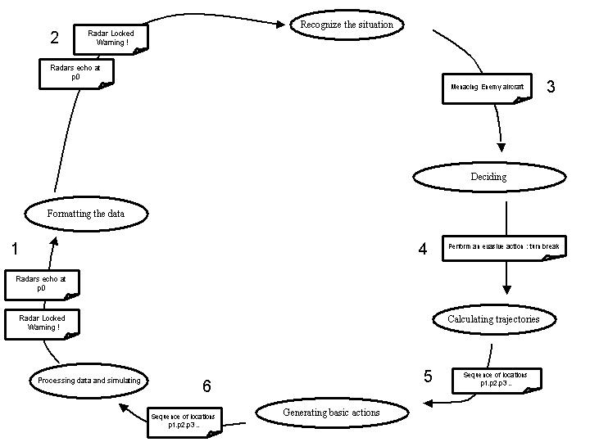 Figure 1: Functional diagram

First the Flight simulator engine provides some data (1). For instance an aircraft position p0 and radar locked warning signal. (2) The formatting data block translates these rough data so that they are understandable by the pilot model. (3) The situation recognizer can process them. A menacing aircraft has been detected. This information is communicated to the decision making process. (4) A turn break is chosen in order to escape the enemy threat. (5) The turn break trajectory is calculated. A sequence of geographical locations is computed. 6) This information is processed and translated so that the flight simulator engine can understand them.

The whole bot will not be developed. Only the decision part will be carried out. From know this decision part will be called Artificial Intelligence Engine (AI Engine)

Input / output diagram

It has been pointed out that the bot has to be able to deal with different kinds of situation. “To deal with”, means to be able to make decisions so that the boat can reach the situation specific goals.
In order to take such decision, the bot needs a kind of AI engine. The bot intelligence is implemented in this engine. Intelligence means the ability to take decisions: processing several kinds of data and adopting the most suitable behavior. As inputs, events are analyzed and as outputs commands are generated.

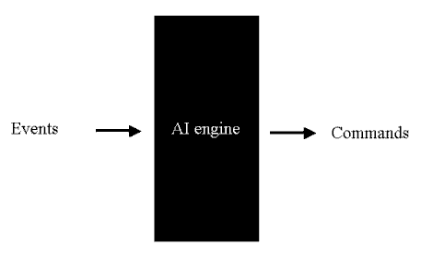
Figure 2: Input / output AI Engine

Here follow the characteristics of this engine:
- All the tasks that consist of taking decisions are assigned to this engine
- These decisions are more deliberative than reactive
- The AI engine should be able to take several parameters into account like the available weapons, the remaining fuel etc
- This is a decision-making system only

Now the inputs and the outputs of the engine are defined more precisely.

Providing commands

Taking decisions determines commands that have to be executed. These commands are high-level actions that do not require decisions anymore. Commands need only know-how skills to be processed. For instance, “engage the enemy” is not a command because you need to decide which kind of maneuvers you are going to perform, which weapon you should select etc. Consequently you need an intelligent process that consists in analyzing facts and making critical decisions. On the other hand, “join the tanker” is definitely a command because the only skill you need is how to proceed the refueling track.

Getting information

The Pilot model gets information in the form of Events. Events are high-level data. The pilot to generate decisions can directly use them. They are dedicated to be used to generate decisions only; they do not require to be processed by any situation recognizer.
For instance “a mig-29 is near enough to engage”, “Mission target destroyed” are events. You can decide to engage an enemy that threatens you once your first priority target has been destroyed. It deals with a decision process. On the contrary, “radar warning”, “aircraft position” are not considered as events because before deciding to toggle in dogfight mode, it is useful to recognize if it is near enough to be dangerous and if it is an enemy. Yet, “radar warning, enemy position < 40 nm” can be relevant enough. It deals with a recognizing process.

They can be divided into two categories:

  - Unexpected events: there are four groups:

Enemy attack | An enemy has locked you, and has launched a missile
Aircraft failure | Your aircraft has been seriously damaged by the enemy
Physiological accident | You are experiencing physiological stresses due to G-forces.
Unexpected environmental event | Turbulences are occurring

  - Expected events: all events related to the flight plan (target destroyed, waypoint reached, runway vacated etc)

What should /not be done?

During the project period, only a little part of the artificial player will be developed. First one should separate what is in the scope of our project and what is beyond to know exactly which part should be carried out. It is the point of this paragraph. This will definitely border the project. Then one should focus on a specific part of the project because designing an entire artificial player pilot is a great time consuming task that takes years.

Firstly, what follows tells about what deals with our skills and what does not.

It is required to:

- Implement the decision making process of the bot. It takes events as inputs and provides commands as outputs.

It is not required to:

- Interface with the Flight simulator engine: it is not required to interface the bot with any flight simulator engine. The decision making process is independent from the flight simulator used. That is why such blocks, as formatting data and generating basic actions will not be developed.
- Assess situation: recognizing the situation from all the rough parameters is not the matter of this project. It will be assumed that this module is operational. How to communicate with it is not yet defined.
- Assess the enemy’s trajectories: this functionality is supposed to be developed. In fact, developing such functionalities is beyond the scope of this project as too much information is missing. It is assumed that a module has been designed and implemented. During the project it will be assumed that these functionalities are operational.
- Calculate trajectories: this functionality uses skills that a pilot has acquired through practice. An artificial player has a memory to learn but data are required. Such rough data as maneuver positions are difficult to find. That is why it is supposed that this functionality is operational.

The challenge is to design the artificial player decision-making process without relying on functionalities as assessing the situation, the enemy’s trajectories etc. Solutions to this issue will be provided in the proposal part of this document.

Then, a specific part of the artificial player will be developed. Working on the dogfight decision-making process is challenging but remains a hard task. Focusing on the attacker behavior is the point of the project. It seems to be a realistic goal to achieve within our project period. This part is more precisely specified in what follows.

Dogfight artificial player

Overview

What is it about?
In this paragraph specifications about the artificial pilot player in a dogfight are given. As it was previously said, only the decision process of the artificial player in a dogfight is carried out (see above about “decision process”)

Which scenario? Which actors?
It is assumed that in the dogfight only two aircraft are involved. To simplify one is supposed to have an advantage on the other one. That is to say one aircraft tries to shoot another one. From now it is called the attacker. The other one tries either to reverse or to escape the situation. It is called the defender or the opponent.

What is the point?
Only the attacker pilot behavior is modeled. The defender is supposed to choose his maneuver in an independent way. The main issue of the pilot model consists in choosing the most accurate maneuver so that it can shoot the opponent. That is to say:

- Positioning his aircraft in order that the enemy is in his weapon parameters.
- Keeping the enemy from employing ordnance against him.

What the dogfight artificial player’s goal?
It is obvious that the first goal of the artificial player is to behave as close as possible to a real pilot when it takes decisions during a dogfight. Thus, he should base his reasoning on the same notions and the same principles as a real pilot. But few data about air-combat are available so that it is hard for us to achieve such a goal.

What is our goal? What are our limits?
As trying to encode a pilot model as close as possible to a real pilot is a little bit ambitious when considering the data available, our first goal should be implementing a pilot model so that anyone can specify and even configure the pilot behavior.

Few data have been found about air-combat domain. In fact, the more precise this knowledge should be the less it is available. For instance, it is easier to get information about the principles learnt by F16 pilots than to know exactly what conditions are required to execute a break turn.

Consequently as long as we have enough knowledge about a specific real pilot behavior, we can specify the corresponding model behavior. Nevertheless, as soon as some information is uncertain or missing about a pilot attitude, an air-combat expert should easily modify the corresponding model attitude.

This ability to be easily modified is a requirement of the program to be developed.

Dogfight model skills

Notions
Here are some notions found in the F16 Handbook [2] that are complete enough. It is required that the dogfight model uses them:

Range, Aspect angle, Angle-off, turning room, Turning Circle vulnerable cone, Lead, lag, pure pursuit, aircraft characteristics, enemy maneuvers, energy state of both aircraft, weapon range, Pilot proficiency, Both aircraft positions, Maneuver risks. These parameters can be easily classified:

- Positional geometry (both aircraft position, angles, range)
- Weapons envelope (weapons range, angle required to shoot)
- Pilot Experience (Pilot proficiency, Both aircraft abilities, abilities to assess the enemy’s maneuvers, maneuver risks)

All the notions are defined in the Appendix A. What follows deals with the principles the real and modeled pilot should base their reasoning on to choose the best maneuver.

Principle
The main principle in real dog fighting is energy considerations. It should be the same for the model. The aircraft has a quantity of energy thanks to its altitude and speed. As a rule of thumb, its energy should always be higher that the opponent’s. In fact, there is a constant trade between energy and position. Getting a position advantage on the opponent costs energy. On the contrary, gaining an energy advantage urges the attacker to loose range or angles. Besides, the ultimate purpose of an attacker pilot is to position his aircraft in weapon parameters. When you are in your opponent’s six hours, you definitely have a positional advantage. A good pilot should ask this question. How much energy or future maneuvering potential can be expended for a given positional advantage? That is why a pilot must constantly balance energy and position.

Approaching the enemy
Some very precise clues have been met in the F16 Handbook. It is required that the artificial pilot behavior enters these states to approach the enemy. To each state corresponds a goal to reach:

- Outside the Turn Circle: entering it
One of the main issues when dog fighting is entering the opponent’s turn circle (TC). Actually, as long as you stay outside his TC, the aspect angle will increase and you will not be able to use ordnance.

- Inside the Turn Circle
The goal is now to solve the problem that has been created while transitioning TC: angles, range, speed etc. That is to say to place the aircraft in a position where ordnance can be employed. The maneuvers to be executed depend on what the bandit is doing.

- Closing for guns
That represents a state when all is made to place the aircraft in gun position. Closing for guns means also small range and speed.

Obviously, a human player is likely to go from one of these situations to another one, depending on what has just happened. So the artificial should be likely too. Therefore, the way the artificial pilot engages dogfight can be represented in a state machine.
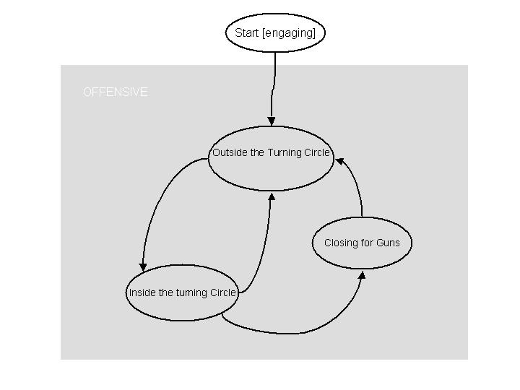
Figure 3: state machine

Note: for additional information, you should refer to appendix B

Functionalities

Designing the dogfight artificial player is a part included in the entire artificial player. Only the dogfight artificial player decision process will be designed. It is a part of the artificial decision process mentioned above. Here are the dogfight artificial player functionalities:

- Storing rules: specifying the decision mechanism in the form of rules is a natural way to represent behavior. Nevertheless it is not required to use production rules. The pilot model stores the rules it uses to choose the most suitable behavior. Those rules should be already loaded in memory at runtime. This set of rules cannot be complete. It would be necessary to have frequent contacts with air-combat experts to acquire this wide knowledge. It is not the case. Consequently, one should easily be able to modify this set of rules (see 2.6).

- Electing: the pilot model chooses the best maneuver in a specific way. It must implement algorithms to fire the rules in memory so that the behavior chosen is the most accurate. Any specifications about these algorithms are beyond the scope of these specifications.

- Maneuver knowledge: Some maneuver features are independent of the context in which they are performed. There are two different types: the destination location of a maneuver when it is executed in a standard way and the initial conditions required (speed, altitude). Usually a real pilot has acquired this knowledge through practice. The model need process such kind of information to take decisions.

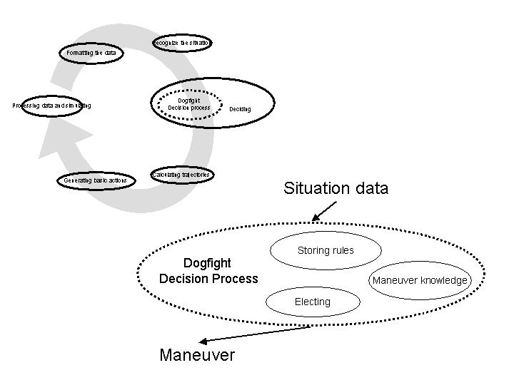
Figure 4: Dog fighter functionalities

The same way as the decision process mentioned in section 2.2.1.3, the dogfight model main functionality is making decision by taking events as inputs and providing commands as outputs.

Input /output diagram

The way a real pilot is modeled should be seen like a black box. It takes inputs and gives outputs. The algorithms used to process these inputs are beyond the scope of this specification part. Nevertheless, it is crucial to set definitely the inputs and outputs of this box.

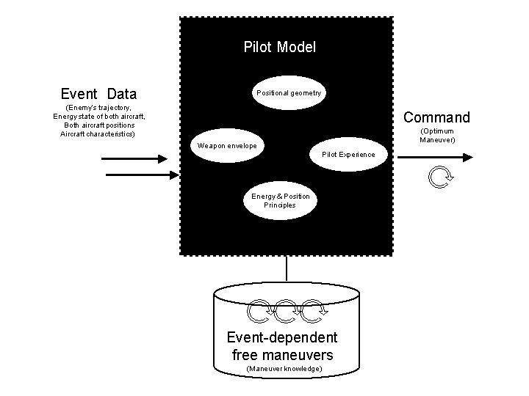 Figure 5: Pilot Model

To take decision the pilot model takes events as inputs.
- Event data are specific to the current situation: aircraft characteristics, energy state of aircraft, enemy’s trajectory, and aircraft positions.

Event-dependent free maneuvers are maneuver knowledge.

The decision process provides commands as outputs:
- The maneuver that is the most adapted to the current situation.

All these inputs/outputs are detailed below.

Inputs
What follows is about the parameters the pilot model takes as inputs:
- Aircraft characteristics: it deals with the features of both aircraft. Normally, it really influences the behavior of both fighter pilots, especially when one knows that the other’s turn performance or max speed is higher. Nevertheless, to simplify this first version of the model, it is supposed that both aircraft are the same. Consequently there are no differences in terms of aircraft envelope.
- Energy state of both aircraft: as for a real pilot it is assessed from the aircraft speed and altitude.
- Enemy’s trajectory: Periodically, the pilot has to re-assess the situation to build his game plan. It includes the enemy’s trajectory. Unfortunately as a real pilot, the model is not able to know for sure what maneuver the opponent is currently performing. It has to take former opponent’s locations into account to predict his future trajectory. This trajectory is assessed from the previous and current opponent locations. The following diagram illustrates how assessed trajectories are used.
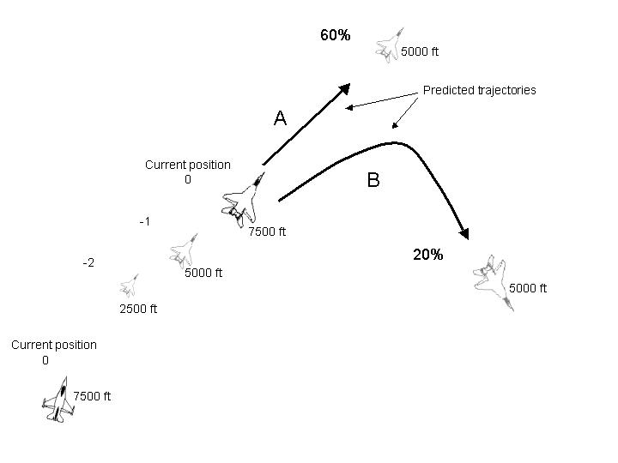
Figure 6: enemy's trajectory

The attacker is in the right and down side corner. He is flying at 7500ft. The altitudes of the defender previous positions are 2500 and 5000ft. Thus, the defender has bled a lot of energy. From current defender’s position, the attacker assesses two paths: a dive from 7500 to 5000 ft (trajectory A) and a turn on the same altitude (trajectory B). The maneuver B is less probable than A because during his zoom maneuver (gaining altitude) the defender depleted a lot of energy. He is not likely to initiate a turn that would probably cost more than a bleed of energy. To perform his next maneuver, the attacker assumes that the defender is about to performing a dive.

- Both aircraft positions: it is assumed that the model has access directly to this kind of information. It is meant relative positions: range, aspect and angle-off.

Parameters | Details | Where from?
Aircraft characteristics | Both attacker and opponent aircraft envelope example | Both aircraft are supposed to be the same.
Energy state of both aircraft | Speed and altitude | Data directly given by the layer below
Enemy’s trajectory | The pilot has to assess what is the opponent’s trajectory to create his game plan. | {Predicted trajectory, probability} provided by the layer below
Both aircraft positions | Relative positions of both aircraft. | Data directly given by the layer below

Outputs
As it has been mentioned, when dog fighting, the artificial pilot has some goals to reach. To manage these goals, it is required for the bot to be able to perform some maneuvers. The way the maneuver to perform is chosen, depends on parameters that have already been defined. Thus, the following chart lists these maneuvers, and gives some clues to take into account to choose the best maneuver to perform. These clues are divided into three parts:
- Technical requirements: Enemy-independent requirements
- Tactical requirements: Enemy-dependent requirements
- Purpose
Maneuver | Technical requirements | Tactical requirements | Purpose
Lead turn |  | - Offset of one diameter  - Aspect less than 180 degrees | Reduce the angle off and aspect prior passing the 3/9 line, roll behind the enemy
High-G lead turn |  | Short range & little offset
Low-G lead turn |  | Long range, big turning room
Vertical lead turn up | - Speed > 450 KCAS  - Height > 5000’ (10000 recommended),  - MIL power | Significant energy advantage | Same purpose as lead turn, but in the vertical plan
Vertical lead turn down | - Height > 15000’  - Speed 300-350 KCAS  - MIL power. | Enemy low and traveling in the opposite direction. | Same purpose as lead turn, but in the vertical plan
Roll | - Attitude > 10000’  - Speed: 300-400 KCAS  - MIL Power | Speed too high | Prevent a flight path overshoot.

Notes
Most of the time, a real pilot does not have enough information to take the most accurate decision. But nevertheless, maneuvers are performed. It should be the same for our model. But in the first approach, it is supposed that all the necessary information to take decision is provided by the low layers. In a second approach, the lack of information will be taken into account.

Dog fight Model limits

Many data are missing. It is very difficult for the model to have as many skills as a real pilot. Here are some examples of crucial data that are missing.

Maneuver Initial conditions
For many maneuvers too few data have been collected, especially about the initial conditions. That is why the pilot model does not take them in consideration.

Maneuver Technical information
For many maneuvers too few data have been collected, especially concerning Ps charts. They provide information about how energy consuming a maneuver is. These maneuvers have been dismissed.

Assessing a maneuver destination location
A serious problem is rising while modeling the pilot decision process. To assess the positional advantage and the energy bleed of a maneuver, it is necessary to have a minimum of information about the destination location of a maneuver.

Before evaluating how much energy a maneuver can cost, it is required to have an idea even vague about its feasibility. Thus it is important to know what are the destination points the aircraft can reach performing such a maneuver.

This set of points will be called destination area. This piece of information need not be very sharp. It is just required to know where approximately a standard kind of maneuvers can lead the aircraft in a standard environment (Altitude, speed etc).

For instance, the following graph shows how this destination area is used to determine if it is worth to perform a max G turn that depletes a lot of energy to reach the opponent six. In the case A, the attacker decides to initiate the max G turn to shoot the enemy whether in case B, it is useless to bleed energy as he knows that it is impossible to position.
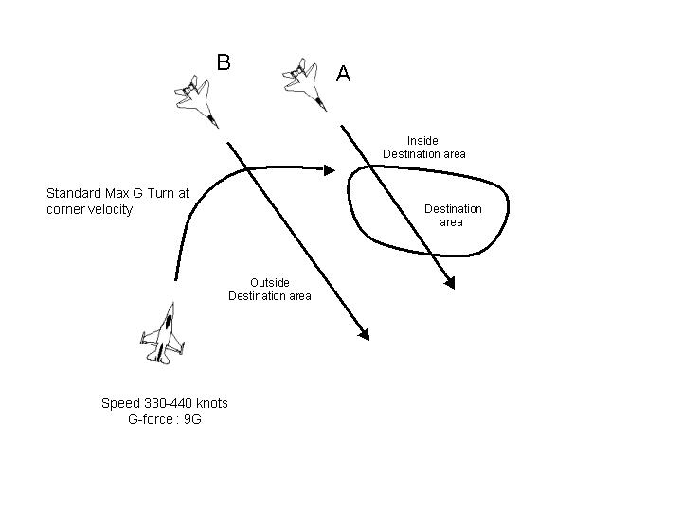
Figure 7: destination area

What should /not be done?

This section is very similar to the section “what should /not be done?” of the artificial player. Anyway, some dogfight-specific requirements have been added:

It is required to:

- Develop the dogfight decision process: given a situation the program should be able to choose the most suitable maneuver.
- Model the attacker behavior: the model has to deal with offensive maneuvers only.
- Model gun attacks: the only weapons used in the dogfight are guns.
- Make it easy to modify: as a lot of information is missing, many data will be set without any air-combat expert intervention. One should easily be able to modify them.

It is not required to:
- Model the defender behavior: it is assumed that a defender model has already been developed. It can maneuver independently. Any reversal situation is beyond the scope of this project.
- Compute a decision if some information is missing: to simplify in a first approach, it is assumed that all information are provided to the model. If some data are missing, the model is not required to provide outputs.
- Interface with the Flight simulator engine, Assess situation, Assess the enemy’s trajectories, Calculate trajectories. (See 2.2.1.6)

Development / working environment

Visualization

It is useful to visualize the decision process of the dogfight artificial player at runtime. The simplest way is to display both input and output in real time. It is required to display them in a text mode, in a console. If it remains enough time the 2D view should be implemented.

Text view
Inputs and outputs are displayed in real time or in slow motion in text mode so that the user can view and check if they are coherent and valid. Input mean events and output mean commands as they were previously defined.
These data are also stored in input and output files that are updated in real time.

2D view
Both aircraft trajectories are displayed in real time or in slow motion so that the user can check if the chosen maneuvers are coherent. It is at least possible to view the horizontal plan where the motions take place and also the vertical plan

Language

The program should be developed in an oriented object language as C++ or JAVA.

Working schedule
- Prototype implementation: this task consists in designing and implementing a dogfight pilot model prototype with few abilities.
- Dogfight Pilot model Design: it deals with the entire dogfight pilot model process. The UML diagram class will be provided.
- Decision Tree: this task is about enumerating pilot model rules. They will be organized in decision tree.
- Implementation: It is the coding of the dogfight pilot model.
- Tests: this phase consists in testing if it works well and how close to the real pilot the model is.
- Report: it deals with the final report of the project.

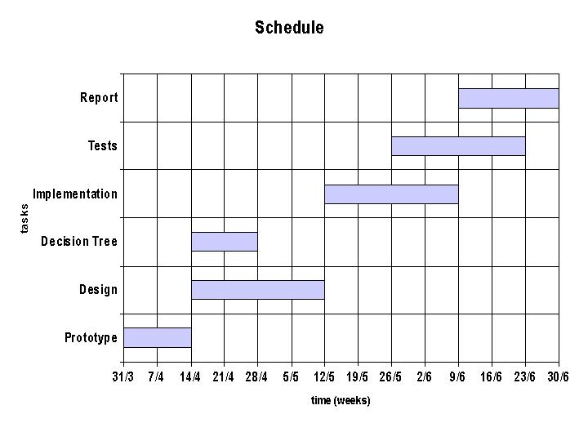 Figure 8: Schedule

Performance

When dog-fighting one needs to make quick decisions. Considering this, the bot reasoning should not last over a few seconds. This constraint must be taken into account when designing the artificial player reasoning process; it should react in real-time to any environment stimuli. Consequently, a balance should be found between its ability to foresee actions and the simplicity of its behavior to react spontaneously when needed.

Flexibility

What has been modeled using uncompleted information should be easy to adjust. What is meant by “easy”?

It can mean:
- One should be able to adjust parameters or algorithms without the intervention of computer science experts. Most of the time, a user interface is necessary but it is task-consuming to develop. It is implied that there is not re-compilation process to be done. The new parameters should be parsed and taken into account without re-compiling the application.

- It should be documented enough that anyone that did not participate to the project development can modify it in a short time. The modification procedures should be closely detailed. Moreover the application design should prevent such modifications from impacting other parts of the program.

Given the fact we are time limited. For sure the second approach will be adopted. Some solution will be suggested to address this flexibility problem: XML …

Proposal

Proposal Overview

The point in this chapter is to propose a solution to satisfy the requirements that have just been set. Following the same plan as the Specifications chapter, it first explains the layered architecture proposed for the artificial player, and then the pilot model suggested for the dogfight artificial player.

Artificial player

Considering the functionalities the artificial player should have (mentioned in 2.2.1.2), and what is required (mentioned in 2.2.1.6) for the project, a layered architecture is proposed for the model. Only main information is given. For more details, confer to Appendix B.

Layered architecture suggested

The purpose is to organize and separate the different artificial player functionalities in order to be able to develop them in an independent way. From the upper layer, one can find the most intelligent functionalities, and from the lower layer one can find the most automated functionalities.
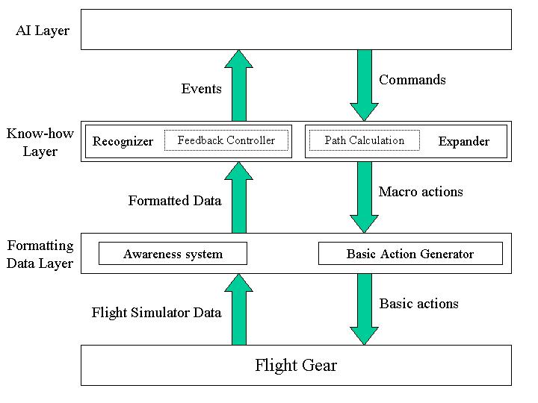
Figure 9: architecture diagram

One can see that all the required functionalities are gathered into that architecture.
Moreover, this architecture makes the AI Layer flight-simulator-independent.

Layer description

Now follows the description of each layer.

Formatting data layer

The aim of that layer is to translate data from the upper layers to the flight simulator and conversely.
  - The Awareness System is the system used to provide the bot with all the world current state information. It gets data directly from the flight simulator. It computes all the information gathered, to make it easier for the bot to use.
  - The Basic Action Generator computes macro actions from the upper layers (ex: go from A to B with information on the route, the speed, the height, etc…) into outputs that can be interpreted by the flight simulator engine. These outputs can be compared to the inputs from a human player (keyboard, mouse, joystick).

Note: This layer will not be implemented.

Know-how layer

This layer contains all the bot’s know-how skills. These skills are used in two different ways:

- To convert the commands from the AI Layer into macro actions.
- To generate events from the information provided by the Formatting Data Layer through a recognizing process. Events characterize what is happening.

Therefore the layer is divided in two functional blocks:
  - The Recognizer takes the data coming from the Formatting Data Layer into account to assess what is happening.
  - The Expander generates the macro actions required to process the commands from the AI Layer.

The Feedback Controlling functionality is part of the Recognizer, whereas the Calculating trajectories functionality is part of the expander.

Note: This layer will not be implemented.

AI Layer

It represents the bot brain where the decisions are taken. It gets events that describe the situation, and then it computes the most adapted solution to face this situation. To reach this goal, a state machine and fuzzy functions are tools that can be used:

  - The State Machine represents the states in which a pilot can stand during a flight (by instance ‘taking off’, ‘landing’, ‘normal flight’, etc…). It also describes what is needed for going from one state to another one. To express how much it wants to have, the bot uses the Fuzzy Engine.
  - The Fuzzy Engine contains all the fuzzy logic rules needed to take a decision from all the information coming from the lower layers.

INPUT: Events from the Know-how Layer Recognizer.
OUTPUT: Commands

It is the only layer that is the point of the current project. Thus building events and providing the AI Layer with them is not part of the subject matter. Only the making decision process is dealt.
More specifically, as it has been defined, focusing on the dogfight attacker behavior is the point of the project. This part is more precisely specified in what follows.

Dogfight artificial player

Pilot model suggested

The pilot model process consists of two phases:
  - Looking at the data provided and interpreting them
  - Applying the decision process to elect the optimal maneuver.

The following diagram illustrates the pilot model process:
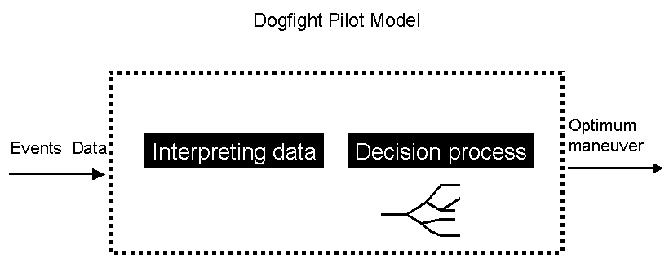Figure 10: Dogfight model pilot

Interpreting data

The point of this section is to give a proposal to the way data can be interpreted by the pilot model. This way of interpreting data is based on our own understanding of the F16 handbook [2]. It has never been extracted from any direct contact with air-combat experts. Consequently, what follows is a suggestion. If modified it should not dramatically impact the development of the project.

In the real pilot making decision process mentioned above, there were the following key words: energy and position advantages, reliability of enemy’s trajectory assessment, maneuver risks. To respect the modeling requirement, these notions should still be used.

The point is not the decision-making process but the way more importance is given to one maneuver instead of another one facing a given situation.

A pilot should know if a maneuver is worth to perform. That is why he must continually find a balance between position advantage and energy advantage. In the same way, the pilot model has to know how much a situation gives a position advantage or an energy advantage. Thus, the two following rates are computed for the current situation and for each possible maneuver.

Position satisfaction rate

It measures how satisfactory the final position is in term of gun shooting capabilities (it can vary between 0 and 1). Thus this criterion depends on three parameters: aspect angle, angle-off and range. The following diagram shows how each parameter can influence the position satisfaction rate (PSR).
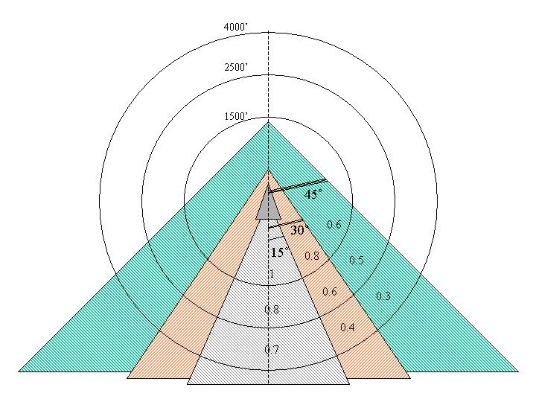
Figure 11: Position Satisfactory Rate values

On the diagram, the defender aircraft is assumed to be in the center. As long as aspect angle stays below 45 degrees, your aircraft is close to the enemy’s 6. Thus it is feasible to gun the enemy. Three angle-windows have been considered to point out how aspect angle can influence the PSR:
- Aspect < 15°: The attacker is very close to the enemy’s 6. Thus he must be in pure pursuit. PSR is high.
- 15° < Aspect < 30°: The attacker is far enough from the enemy’s 6 to engage lead pursuit. Otherwise, if he directly points at the target and fires, the bullets will pass behind the target. PSR is still comfortable.
- 30° < Aspect < 45°: The attacker is not so close to the enemy’s 6. Attempts to gun him are not very likely to succeed

The angle-off evolution is related to the aspect one. Depending on the aspect value, the attacker has to point his nose more or less in front of the defender.
Since you need to be close in range to the enemy to gun him in an efficient way, the PSR also depends on the range. This influence can be seen in the diagram. Three range-intervals have been considered:
- Range < 1500 feet
- 1500 < Range < 2500
- 2500 < Range < 4000
The closer to the defender the attacker is, the higher the PSR is. Beyond 4000, range is to high, and the position is not satisfactory.
The model is quite simple. However, it is based on some points of reference that corresponds to diagrams gathered at this website [3]

Energy difference rate

The energy difference rate stands for the energy depleted during the maneuver time compared with the energy consumed by the opponent. If this difference is positive then it is satisfactory. There are two different ways to assess how much energy a maneuver is going to deplete.
- It is supposed that you have enough information about the destination location of the maneuver. You know where the maneuver will lead the aircraft. Thanks to the following formula $ΔE={ΔE}_{k}+{ΔE}_{p}$ where $E_{k}$and $E_{p}$ stand for Kinetic Energy and Potential Energy, it possible to calculate how much energy is consumed.
- It is supposed that you have enough information about the aircraft energy consumption for specific maneuvers. For instance, it is the case concerning the turn maneuver. A Ps chart provided in the Falcon 4.0 handbook [4] shows a series of fluid lines that represent energy states of the F16. It provides numerical data about the F16 abilities to keep energy in different kinds of turn. Of course it depends on speed and turn rate. Unfortunately, such charts are not available for all the F16 maneuvers. Here is the Ps chart mentioned above:

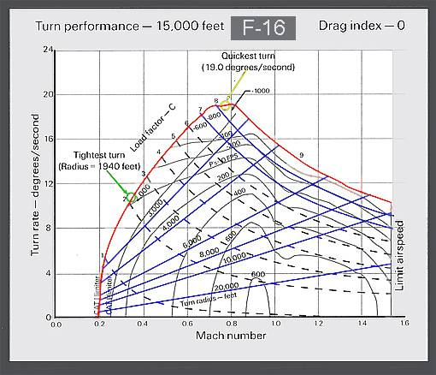
Figure 12: Turn Ps chart

For a given turn rate and speed you can check on the chart if the turn you are performing is an energy-saving or consuming maneuver. In fact, the Ps lines with positive numbers represent where the aircraft has the potential to gain altitude or airspeed.

Risk rate

One of the most important matters for fighter pilot is to keep the enemy from employing his ordnance against him. It is relevant to take these parameters into account:
- Tactical risks
  - How far the opponent is from you vulnerability cone.
  - Minimum Kinetic Energy
- Technical or physical risks
  - Minimum altitude
  - Minimum Range
  - How close to the aircraft limits
  - Pilot capacities.

Reliability rate

Given an opponent’s location, several trajectories can be predicted. Nevertheless, some of them are more reliable than others. Due to the fact that a pilot adapts his game plan to the adversary attitude, it is vital to know if you can trust in the information on which you base your decision.

The following section directly deals with the reasoning process. A first way to address the problem is given.

Reasoning process (First approach)

As mentioned in the specification chapter, the model should be easy to modify when the modeling has been made through uncertain data. It is the case for the reasoning process. It should be easy to adapt.

A human being reasons with his brain. Through experience, he knows what should be done. For an artificial player model, the only way to simulate experience is keeping this kind of rules in memory. Thus, the decision process should have direct access to it.

Firstly, production rules will be used and directly loaded in memory. The hierarchical structure that corresponds is decision tree.

Decision tree

Each node of the tree is associated with a condition that has to be satisfied in order to enter the node. Each leaf is associated with an action. A branch represents a rule that has as conditions the conjunction of all conditions in the arcs of the branch and as actions the actions in the leaf.

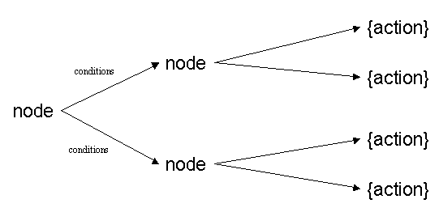
Figure 13: Decision Tree

Actions or Basic maneuver

‘Basic maneuvers’ is a more accurate term than ‘actions’ when it deals with aircraft. ‘Basic maneuvers’ will be used instead of ‘actions’ in what follows. Basic maneuver is roll, acceleration, turn, dive, zoom, etc. A sequence of basic maneuvers defines a maneuver. For instance, a “high yoyo” is composed of a turn and zoom.

Here is an example of a decision tree branch:

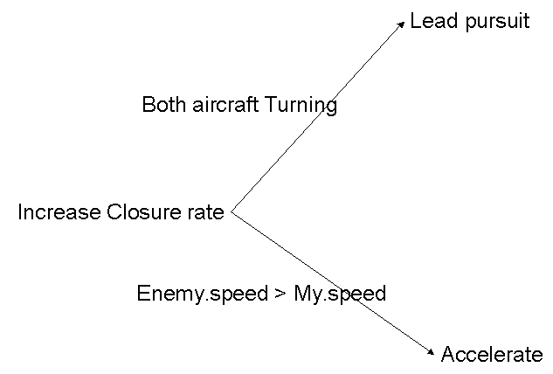
Figure 14: Decision Tree Sample
The root represents a situation. The attacker should increase the closure rate. The decision he is about to take depends on two parameters. If both aircraft are engaged in a turn, the best way to get closer to the enemy is to point in front of the defender. It is called lead pursuit. Besides, if the enemy’s speed is higher than the attacker’s, he should accelerate. Both conditions are not exclusive. Sometimes it can be. But this has not yet been set.

Prototype

This first approach will be implemented in a first prototype. A report will be provided when the designing process is achieved. After some tests, it will be possible to see if this approach is satisfactory. But for sure, it is very likely that probabilities should be involved. Most of the time, there is not enough information to assess the situation. It means that there are not enough satisfied conditions to fire the rules. In this case, suppositions should be made to fire rules because decisions have to be taken. Suppositions mean dealing with probabilities. Moreover, the pilot has to know how much he can rely on the decision he took. It can be the point of an advanced reasoning process.

Testing the model

One of the challenges of this project is to test the pilot model given that many abilities have not yet been developed. Some clues are given about how these problems can be addressed:

Computing trajectories

In 2.2.2.5, it has been mentioned that some data will definitively be missing especially about the maneuver destination areas. Some solutions have been discussed:
- The destination location of maneuvers can be set considering our own experience. Trajectory can be considered as ideal curve, that is to say all the F16 model constraints will be simplified. Curves will not depend on F16 features, but this should be adjusted later.
- Some standard maneuvers can be executed on a F16 flight simulator as Falcon 4.0. Data like destination locations can be logged and used to provide information that look like as closely as possible the reality to the model.

No defender model

In 2.2.2.6, it is mentioned that the defender will not be modeled. In fact, to address this problem, the defender attitude, the defender’s sequence of maneuvers, will be provided in an input file.

No enemy’s trajectory assessment

In 2.2.2.6, it is mentioned that assessing the enemy’s trajectory does not belong to the model abilities. Thus, data like {Predicted trajectory, probability} will be provided as input file to the model.

Bibliography

[1] Intelligent Agents for Aircraft Combat Simulation, S. Coradeschi, L. Karlsson, A. Törne, Department of Computer and Information Science Linköping University, Sweden.

[2] MULTI-COMMAND HANDBOOK 11-F16, VOLUME 5, 10 MAY 1996, Supersedes MCM 3-3 Volume 5, 1 September 1992

[3] The Simulation Community’s Headquarters:
http://www.simhq.com/simhq3/sims/air_combat/f3manual/bfm1.shtml

[4] Falcon 4.0 handbook, MicroProse.

Appendix

Appendix A: Real pilot reasoning process

Appendix B: Artificial pilot layered architecture

